**The Hilbert Transform**

The Hilbert Transform is referred to as a multiplier transform. It is used to affect the Fourier Transform, to obtain the analytic signal. It cannot simply be applied to a raw EEG signal by itself. The steps to be taken to acquire its output are displaying in a simplified form in the following diagram:

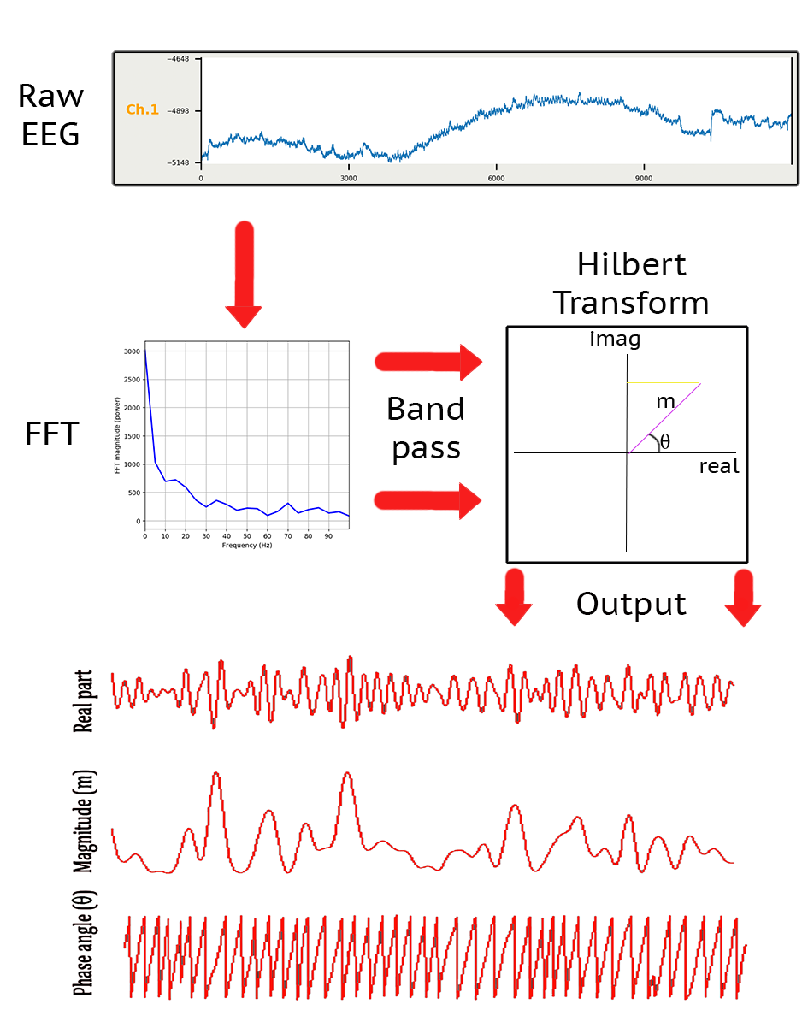

To explain the steps taken above, in more detail:

1. Firstly we input our raw EEG waveform.
2. Next we take the Fours Fourier Transform of our EEG data to display the distribution of signal energy through frequency. The particular frequencies we are interested in are between 0.5 Hz – 50 Hz. Anything higher than that is less useful data, and harder to discover ERP patterns within.
3. We use a butterford band pass to select the specific frequency range we are interested in. So, for example, we may band pass between 8 Hz – 13 Hz to specifically inspect alpha waveform patterns. It is important to note that the Hilbert Transform is only interpretable when it is applied to narrow band time series data (via a band pass). EEG data is broadband and is inherently noisy and so must be band passed.
4. After this band passing has been done, we do the inverse FFT on our data.
5. Lastly we apply the Hilbert Transform, which will turn every data point along our waveform into a complex number, consisting of a real and imaginary part. These complex numbers are essentially 2D vectors, shown in the diagram, consisting of two components: magnitude and phase angle. The imaginary number (phase angle) is obtained by essentially phase shifting the real component 90-degrees on the complex plane.
6. It’s not shown in the diagram, but from this point you can now acquire the Hilbert envelope, which is the amplitude response.

To produce the amplitude envelope of a signal x(k), we take the Hilbert transform of the signal H(x(k)) and use the computation:

$$Hilbert Envelope= \sqrt{{x\left(k\right)}^{2}+{H(x\left(k\right))}^{2}}$$

The Hilbert transform is thought of as an alternative method for extracting the magnitude and phase angle information from the EEG data, while also removing all negative frequencies.

The Hilbert transform of a function of time (a signal) $u(t)$ is given by:

$$H\left(u\right)\left(t\right)= p.v. \int_{-∞}^{∞}{u\left(τ\right)h\left(t-τ\right)dτ=\frac{1}{π} p.v. \int_{-∞}^{∞}{\frac{u\left(τ\right)}{t- τ} dτ}}$$

While the Hilbert transform can be quite cryptic, as mentioned before, it can be easier to think of it as a multiplier transform of the Fourier transforms. The Hilbert transform *H* of a signal *u* is related to the Fourier transform *F*, like so:

$$F\left(H\left(u\right)\right)\left(ω\right)= σH\left(ω\right)∙F(u)(ω)$$

given that,

$$σH\left(ω\right)= \left\{\begin{aligned}i for ω< \\ 0 for ω=0 \\ -i for ω>0\end{aligned}\right.$$

So we apply a Hilbert transform by multiplying all negative frequencies by i and all positive frequencies by –i, leaving any DC component untouched. This is perhaps not intuitive, but we can gain some additional insight by thinking about it geometrically.

Euler's formula helps us to see that to rotate any complex number by a specific angle α, we must multiply it by the complex number $e^{iα}=cosα+isinα$. We see that multiplication by i alone, as in the equation above, is equivalent to a rotation by 90°. When we take the inverse Fourier transform, the result is a phase-shifted version of our signal.

**Testing the Hilbert Transform**

With the path towards attaining the Hilbert Transform established, we can now set about testing our data to see if it is outputting the correct response. The basic transforms below were used as a comparison to test if I have implemented the Hilbert Transform correctly.

|  |  |
| --- | --- |
| **Signal $$u(t)$$** | **Hilbert Transform $$H(u)(t)$$** |
| $$sin⁡(t)$$ | $$–cos⁡(t)$$ |
| $$cos⁡(t)$$ | $$sin⁡(t)$$ |
| $$\frac{1}{t^{2}+1}$$ | $$\frac{t}{t^{2}+1}$$ |

Table of selected Hilbert Transform

Inputting the following data should produce the accompanying graphs listed in the table.

**The Importance of the Hilbert Transform**

The idea of the Hilbert Transforms is that we can take real-valued time series and estimate the phase angle, magnitude and power, while removing all the negative frequencies. It was once said of the Hilbert Transform:

“The Hilbert transform is, without question, the most important operator in analysis. It arises in so many different contexts, and all these contexts are intertwined in profound and influential ways. What it all comes down to is that there is only one singular integral in dimension 1, and it is the Hilbert transform. The philosophy is that all significant analytic questions reduce to a singular integral; and in the first dimension there is just one choice.”

It acts as an alternative to complex morlet wavelet convolution to attain these useful variables. As well as being used in EEG studies, the Hilbert Transform is used in the field of seismology to analyse earth quake readings.